Network Scenario 2:
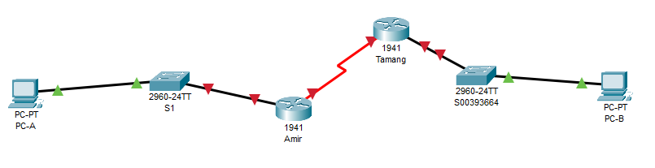
Figure: Existing network architecture

- Modification of Network architecture.
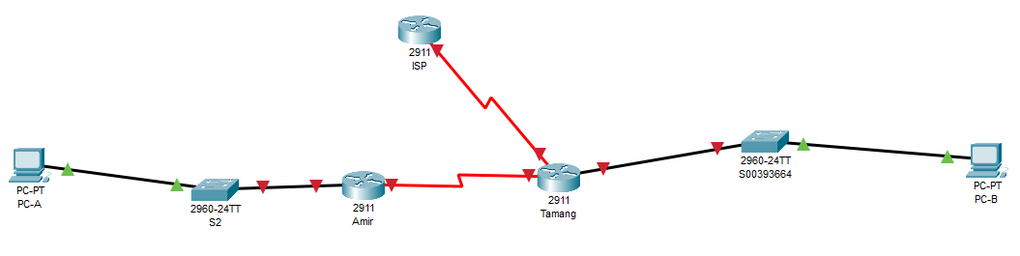
Fig. Modified network architecture.

- Assigning IP addresses for all devices and interfaces.
Device | Interface | IP Address | Subnet Mask | Default Gateway
PC-A | Fa0 | 192.168.1.10 | 255.255.255.0 | 192.168.1.1
Switch S2 | VLAN1 | 192.168.1.2 | 255.255.255.0 | 192.168.1.1
Switch S00393664 | VLAN1 | 192.168.1.3 | 255.255.255.0 | 192.168.1.1
Router Amir | Gig0/0 | 192.168.1.1 | 255.255.255.0 | -
Router Amir | Se0/0/0 | 192.168.3.1 | 255.255.255.252 | 192.168.3.2
Router Tamang | Se0/0/0 | 192.168.3.2 | 255.255.255.252 | 192.168.3.1
Router Tamang | Gig0/0 | 192.168.2.1 | 255.255.255.0 | -
PC-B | Fa0 | 192.168.2.10 | 255.255.255.0 | 192.168.2.1
Router Tamang | Se0/0/1 | 192.168.4.2 | 255.255.255.252 | 192.168.4.1
Router ISP | Se0/0/0 | 192.168.4.1 | 255.255.255.252 | -

I am now setting a default route from Router Amir to ISP. Similarly, a default route is set for Router Tamang.

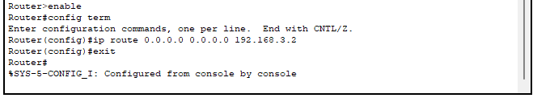
I am setting a return route for two routers, Amir and Tamang.
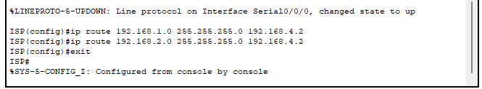

- Device Configurations:
- Configuration for ISP (Router):
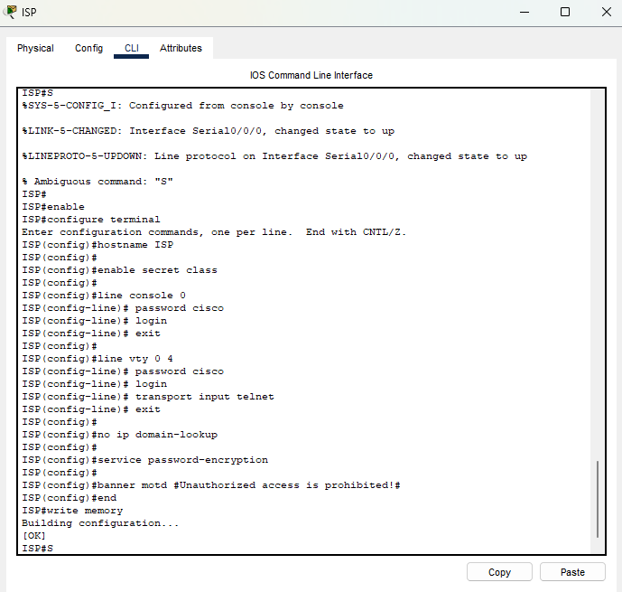

- Configuration for Amir (Router):
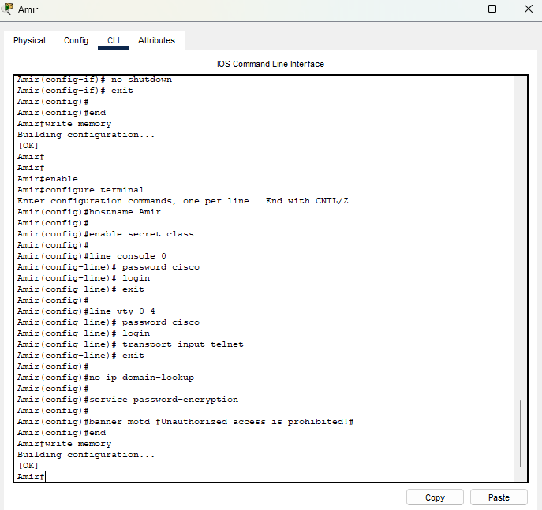

- Configuration for Tamang (Router):
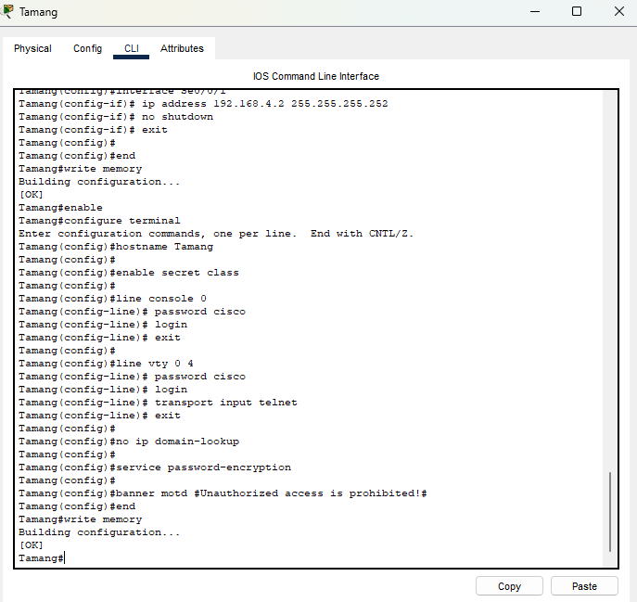

- Configuration for S2 (Switch):
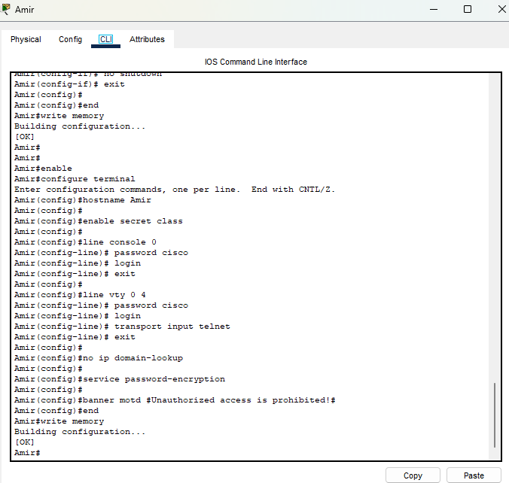

- Configuration for S00393664 (Switch):
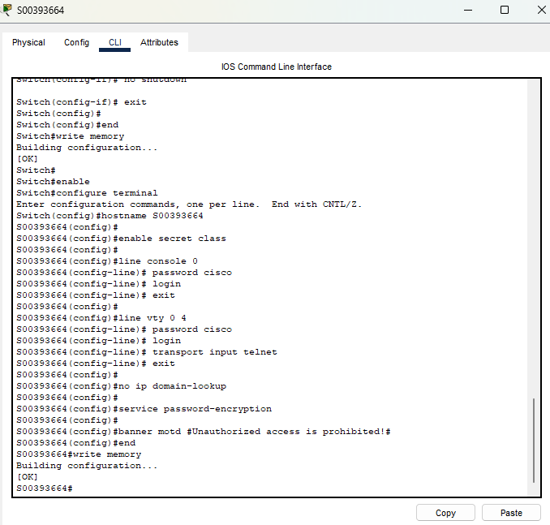

- Enable remote SSH access to switch S2:
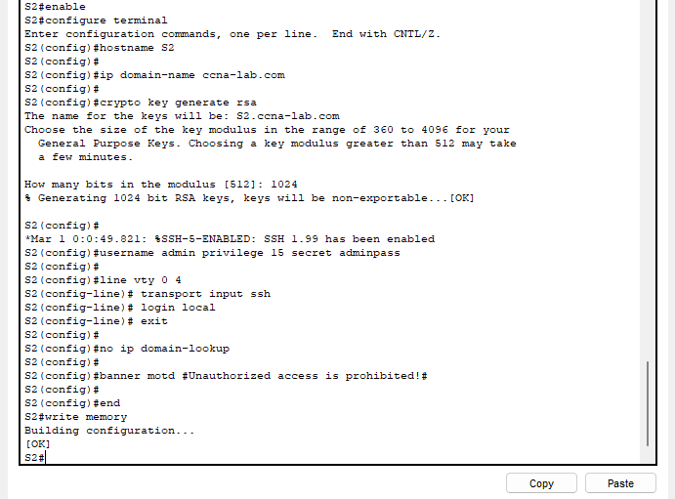

- Test connectivity:
  - Ping PC-B from PC-A
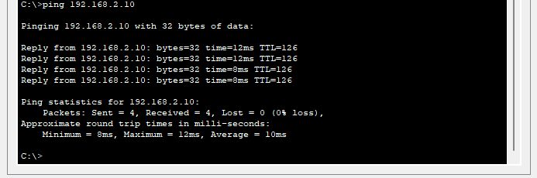

  - Use SSH to remotely access the switch S2 from PC-A
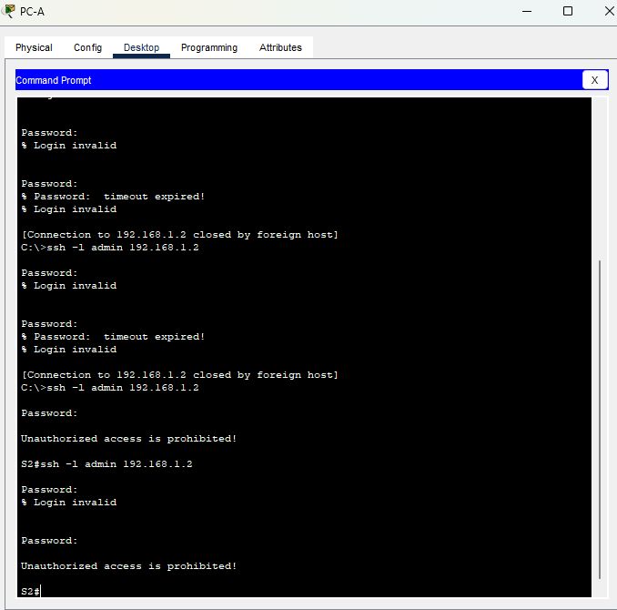

  - Use telnet to remotely access router Amir from PC-B
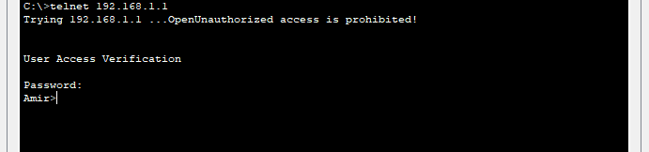

Answer the following questions based on your network design:
- Identify the protocols and their functionalities used at different layers of the TCP/IP model. You need to identify at least two protocols for each layer that can be used to send and receive data packets between two devices in your network.
- Protocols and Their Functionalities in the TCP/IP Model are as follows:
- Application Layer
- Hypertext Transfer Protocol allows the transfer of hypertext documents across the Web.
- The File Transfer Protocol allows for file transfers from client to server.

- Transport Layer
- TCP guarantees reliability and ordering in the delivery of data across applications. It establishes a connection before data delivery.
- The connectionless communication architecture with UDP is suitable for applications where high speed without delivery guarantee overhead is needed.

- Internet Layer
- It provides the packet addressing function and routing of networks. It defines the format of the addressing scheme and the packets.
- ICMP-Internet Control Messaging Protocol provides the operational data, like ping, and the error messages used for diagnosis.

- Network Interface Layer
- Ethernet protocol identifies where packets of data are sent through the wired LAN.
- Wi-Fi refers to a group of IEEE 802.11 wireless LAN protocols used for connectivity.

- Effective network design takes several critical factors into consideration such as cost, time, scalability, and sustainability. How can an effective network design have positive effects on our social life and on the environment?
- Positive Effects of Effective Network Design on Social Life and the Environment are as follows:
- A well-structured network will ease communication on social, work, or educational platforms since the connections it avails are reliable and easy to access to get in touch with the people or communities. The rise in connectivity this offers will also drive collaboration, creativity, and bonding socially.
- A well-designed network can let people be as effective at home as elsewhere. Saves time and money because there is no physical commuting, which means less carbon emissions and therefore environmental friendliness.
- A properly planned network allows for its easy scalability, hence enabling communities and enterprises to easily adapt to various demands without having to redesign the overall architecture. It can favor sustainable growth by offering effective resource management.
- Smart grids for energy distribution or traffic management systems can be counted as just two of the innumerable ways a solid network architecture can help with better management of resources. It would contribute to building a greener world by being productive and cutting down on waste.
- Well-planned networks can stimulate access to online support groups and virtual health facilities, hence contributing to individuals' well-being by providing them with the required resources and support, while reducing their need for physical travel in this regard and minimizing the contribution of that travel to environmental degradation.

